SOCIAL MEDIA
Social Hashtags | #BNHF26
Date: Run from 20 July – 2 September  MESSAGE:  PROGRAMME IS NOW LIVE  - Please review the social media images within your marketing pack. | We’re delighted to say that the Big Norfolk Holiday Fun programme is live this school holiday.  Active Norfolk and Norfolk activity providers have helped facilitate multiple fun activities designed for children aged 5-16 during the holidays, with free slots for children who receive benefits-related free school meals.  Parents and carers can book their child’s holiday activities using our activity finder: Big Norfolk Holiday Fun · Eequ  To read more about the impact on children, families, and providers, access Active Norfolk’s most recent Impact Report here: Work Programme: Big Norfolk Holiday Fun - Active Norfolk
Date: 20 July – 2 September  MESSAGE:  BNHF IMPACT  - Please review the social media images within your provider marketing pack. | The Big Norfolk Holiday Fun programme is now in full swing, with children and young people eligible for benefits-related free school meals accessing quality provision across Norfolk.  Watch a case study that helps demonstrate its impact over the past few years in further detail:  Pick from one of three case study videos. Each video has a different angle you may want to convey to reflect your organisation’s values.  - Big Norfolk Holiday Fun: Top Banana (youtube.com) Top Banana (Cycle club, skill-building, physical activity and healthy eating)  - Big Norfolk Holiday Fun - East Norfolk 6th Form (youtube.com) East Norfolk Sixth Form College (Education, physical activity, youth coaches using the programme as a means of gaining experience)  - Big Norfolk Holiday Fun: Echo Youth Theatre (youtube.com) Echo Youth Theatre (arts and heritage, SEND and 1-2-1 support, improved provision brought by the programme funding)  To read more about the impact on children, families, and providers, access Active Norfolk’s most recent Impact Report here: Work Programme: Big Norfolk Holiday Fun - Active Norfolk

WEBSITE AND NEWSLETTER COPY
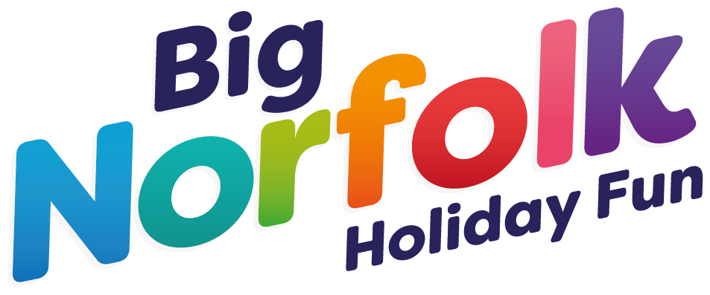 | The Big Norfolk Holiday Fun (BNHF) activity programme provides holiday activities for children and young people aged 5-16 (or 4 if your child is in reception) in Norfolk.  The UK Government’s funding for the programme has been extended for a further 3 years, after 5 initial years of their support.  Children who receive benefits-related free school meals can claim free spaces on the activities, whilst paid spots are available on many activities for those who don’t.  If you feel your child/ren could benefit from a free place but are NOT entitled to Free School Meals, please contact us to discuss applying for an Awarded Place. More info on this HERE  Find out more about this in Active Norfolk’s FAQ section.

