Secondment Opportunity for Organisations in King’s Lynn & West Norfolk
Sport England Place Partnership – King’s Lynn & West Norfolk (KLWN). The King’s Lynn & West Norfolk Health & Wellbeing Partnership and Active Norfolk are partnering with Sport England to address high rates of inactivity in KLWN. Through the Place Partnership workstream, there is a unique and exciting opportunity for organisations, institutions and groups working in King’s Lynn & West Norfolk to improve community outcomes via increased physical activity. During an initial 6 month trial phase, we are implementing a Shared Role (Secondment) Model. This approach aims to give organisations the time, support and resource to explore how physical activity can improve your communities’ outcomes and help the attainment of your organisational objectives. We are inviting local organisations, institutions and groups in KLWN to express their interest in this opportunity.
How will it work? Up to 10 organisations will be selected to undertake the Shared Role (Secondment) model over a 6-month period with the potential to extend this for a further 6 months. Each organisation will identify a current employee (West Norfolk MOVES Champion) to step away from their routine responsibilities for one day per week. The West Norfolk MOVES Champion’s salary costs will be covered for this period (one day per week for 6 months), enabling the backfilling of existing capacity. Through a structured process led by Active Norfolk, the seconded officer will co-locate with other West Norfolk MOVES Champions on a fixed, weekly day, exploring how positive physical activity practices can be embedded in their respective institutions. The West Norfolk MOVES Champions will lead on tasks that will culminate in the design, delivery and evaluation of bespoke evidence informed Test and Learn projects.
Shared Role (Secondment) Timeline. The provisional timeline will run from the Week Commencing June 1st 2026 through to December 2026. We anticipate the fixed day to run on a Monday. We welcome expressions of interest from all organisations working in King’s Lynn & West Norfolk. To find out more or to arrange an informal chat, please contact Becky Gillick (becky.gillick@activenorfolk.org) or Rebecca Tuff (Rebecca.tuff@activenorfolk.org).
To submit an Expression of Interest, please complete the form attached to the end of this document before 13th April 2026 at 17:00. Please send the completed form to Becky Gillick on the email above. Expressions of Interests will be reviewed by a panel made up of Active Norfolk and Borough Council colleagues and a decision will be expected on 20th April 2026.
Job Title: West Norfolk MOVES Champion Shared Role (Secondment) Model.
Location: King’s Lynn (Community-based)
Contract Type: Part-time (1 day per week), 6-month secondment, possible extension to 12-months
Reporting to: Healthy & Active Lifestyles Group (HALG) / Place Partnerships Project Lead

Purpose of the Role
The West Norfolk MOVES Champion will play a pivotal role in supporting organisational change to make services more “physical activity friendly”. This role is designed to give selected organisations the capacity and capability to embed sustainable practices that encourage inactive residents to become more active.
The Champion will act as an internal advocate for physical activity, working collaboratively with other organisations and partners to identify barriers, implement practical changes, and share learning as part of the King’s Lynn & West Norfolk Full Award

Key Responsibilities
- Organisational Reflection & Change
- Use a reflective workbook to assess current policies, practices, and service delivery touchpoints that impact physical activity.
- Identify opportunities for embedding physical activity into organisational processes and culture.
- Community & Service User Engagement
- Explore how service user voice is captured and how this can inform physical activity initiatives.
- Work with colleagues to integrate physical activity conversations into existing service delivery.
- Collaboration & Partnership Working
- Participate in co-location sessions and cross-organisational workshops to share insights and learnings.
- Contribute to system-wide action planning and strategy to support the implementation of the Full Award bid.
- Reflective Practice & Reporting
- Maintain a reflective log to capture insights, challenges, and progress.
- Provide regular updates to the Healthy & Active Lifestyles Group and contribute to evaluation reports.

Person Specification
Essential:
- Current role involves community or service-user facing responsibilities.
- Strong understanding of local context and community needs in King’s Lynn & West Norfolk.
- Ability to influence internal processes and engage colleagues in change initiatives.
- Good communication and collaboration skills.
- Commitment to co-locate with West Norfolk MOVES Partnership working group every Monday at central venue (tbc) in King’s Lynn.
Desirable:
- Experience in health, wellbeing, or physical activity promotion.
- Familiarity with organisational development or change management principles.

Support Provided
- Capacity: Salary costs covered for 1 day per week to enable backfill of service provision.
- Capability: Access to a tailored development training package.
- Resource: Communal funding pot for “test and learn” initiatives.
- Co-location: Neutral community venue for collaborative sessions.

Duration & Commitment
- 6-month secondment 1 day per week dedicated to the role, with the possibility for the secondment to be extended for a further 6 months.

Frequently Asked Questions
Q. What type of organisation are you aiming to work with?
A. We are aiming to work with passionate organisations in King’s Lynn & West Norfolk, who are looking to improve outcomes in their underrepresented communities. Organisations could include, but are not limited to: Charities, Schools, Local Authorities, Town Councils, Police, Job Centres, Workplaces, Leisure Centres, Libraries, Care Homes, Mental Health Services, Housing Associations and many more.
Q. What are the expectations of Active Norfolk, The West Norfolk MOVES Champion (Secondee) and the Secondee Organisation?
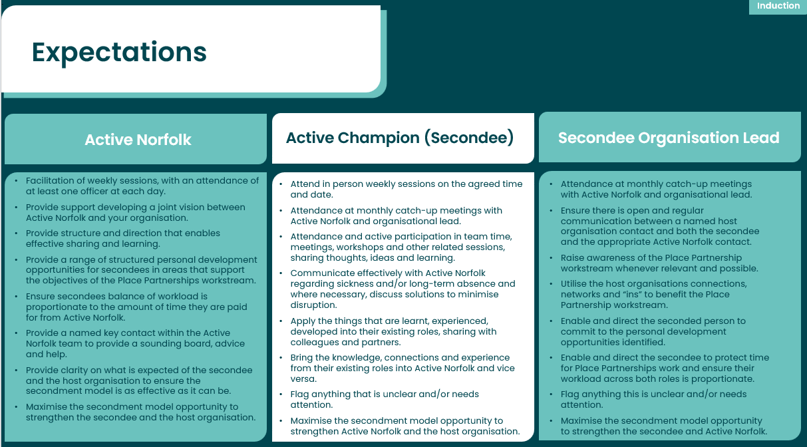
A. A synopsis of the expectation is provided below.

Q. What will the benefits be to our organisation?
A. We anticipate numerous benefits for your organisation, secondees and senior leaders. Benefits include:
- Increased collaboration with Active Norfolk and other local stakeholders
- Developing bespoke interventions aimed at your target audience that support your organisational objectives
- Greater understanding of your target population, workforce, policies, practices, spaces and places
- Training opportunities for secondees that support personal and professional development (including Clifton Strengths).

Q. What characteristics should the West Norfolk MOVES Champion possess?
A. The West Norfolk MOVES Champion should be an employee who is involved in the operational delivery of your service/organisation, working directly with, or being a touchpoint for, interactions with your target population. This opportunity is not designed for a strategic lead. The role will include interacting with service users, colleagues and organisations, the West Norfolk MOVES Champion should therefore be confident to in engaging with a broad range of stakeholders. We would like to see individuals who are curious, courageous and creative to develop and implement innovative test and learn projects. The West Norfolk MOVES Champion will be required to work with other champions and therefore will be able to collaborate or work in partnership with external stakeholders. We want individuals who are passionate and enthusiastic about improving lives of their community, empathetic to the challenges faced by underrepresented groups in our community and a willingness to learn, reflect and develop.
Q. How will progress be reported to senior organisation leads?
A. Active Norfolk will provide a direct point of contact for senior leads. We recommend a formal meeting (minimum every 3 months) to discuss work undertaken, with monthly updates via email. We would encourage more frequent meetings where availability allows, to enable senior leads to shape prospective work.
Q. What does the structure of each day look like?
A. Each day will be split into morning and afternoon sessions. The morning sessions will be split into 3 x 45 minutes slots, with specific focus areas. These will include education sessions, group tasks, workshops and guest speakers. The afternoon session will be flexible and unstructured, enabling West Norfolk MOVES Champions to complete tasks related to a “Reflective Workbook”, planning, researching and actioning as well as 1:1 catch ups with Active Norfolk.
Q. What are the key landmarks involved in the approach?
A. West Norfolk MOVES Champions will undertake various tasks which will ultimately culminate in the design and delivery of Test & Learn Projects. Key landmarks across the 6 months include identification of a joint shared vision (what we want to achieve), engagement of your target population and workforce, reviewing internal policies & procedures and places & spaces, reviewing insight and co-designing evidence informed interventions, starting up and developing interventions and reflecting upon and evaluating test and learn projects.
Q. What could Test and Learn projects look like?
A. Test and Learn projects do not have to be delivery of physical activity opportunities. Examples could include training to develop workforce confidence in having conversations with service users, adapting internal places and spaces to encourage activity, communication / marketing support or enabling changes in policies and procedures. This will vary from project to project, reacting to the need from engagement.
Q. How are Test and Learn Projects funded?
A. Funding is available to deliver relevant Test and Learn projects. Test and Learn proposals will be developed through the structured process. Proposals will be reviewed by the Healthy & Active Lifestyles Group, who will ensure they meet the eligibility criteria. Active Norfolk will guide you through this process.
Q. Why are you undertaking the Shared Role (Secondment) Model? Why not hire additional staffing capacity to do this?
A. The model emphasises sustainability by leveraging existing networks and resources, ensuring sustainability beyond the Sport England Place Partnership investment. Following the completion of the secondment approach, the West Norfolk MOVES Champion will return to their organisation and fully utilise their additional knowledge and connections to better support communities.
Q. What will happen after the 6-month/12-month secondment phase?
A. The West Norfolk MOVES Champion will return to their original role. We anticipate this process will stimulate bespoke Test and Learn projects that will be developed to support our mutual objectives. Active Norfolk will continue to work in partnership with you to develop and sustain successful pilots and work to embed these in your service. West Norfolk MOVES Champions will also be invited to join the Healthy & Active Lifestyles Group with like-minded individuals who support our local approach to address inactivity.
Q. How will applications be reviewed?
A. Expressions of interest will be reviewed by a panel made up of colleagues from Active Norfolk and the Borough Council of King’s Lynn & West Norfolk, and a collective decision will be made via this panel.

Shared Role (Secondment) Model – Expression of Interest Form
Please complete this form and send to Becky Gillick (becky.gillick@activenorfolk.org) before 13th April 2026 at 17:00.
Your Organisation
Organisation:
Address:
Are you a registered charity? If so, please provide your charity registration number
Senior Lead contact details
Lead contact name:
Role, email and contact number:

Proposed West Norfolk MOVES Champion (Secondee)
Name:
Role, email and contact number:

Salary contribution requested for secondment :(total 26 days). Please provide breakdown.
Is the secondee available on a Monday for face to face working? | ☐ Yes  ☐ No
Additional information
Please tell us about the work your organisation currently undertakes in King’s Lynn & West Norfolk (max 100 words):
Please tell us about why you are interested in this opportunity (max 100 words):
Please tell us what you expect to achieve from this opportunity (max 100 words)
Please describe the key qualities, knowledge, or experience your organisation would bring to this secondment, and how these would support your success in the role (max 250 words)

How will the West Norfolk MOVES Champion manage other responsibilities during the secondment? (max 100 words)
Please confirm the secondee, line manager, and organisational leads have discussed this EOI | ☐ I confirm this expression of interest has been discussed with the secondee, line manager and organisational leads prior to submission.

